Nombre_______________________
Clase: ___________
Tarea #: __________
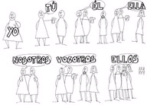

Tú or Usted [Ud.]

Tell me if you would use Tú or Ud. When addressing these individuals directly.

- Your best friend ______________
- A judge ______________
- A flight attendant ______________
- Your teenage brother ______________
- Your soccer teammate ______________
- Your coach/teacher ______________
- A gardener who works for you ______________
- Your mother ______________
- Your grandfather ______________
- A clergy member ______________
- A police officer ______________
- Your girlfriend/boyfriend ______________
- Your counselor ______________
- Your dad ______________
- An aunt ______________
- The maid at the Hilton ______________
- the kid next to you ______________
- Your Spanish Teacher ______________
- Your future father-in-law ______________
- Your little cousin ______________

